**Charotar University of Science and Technology (CHARUSAT)**

**Faculty of: Computer Science and Applications**

**Name of the Institute: Smt. Chandaben Mohanbhai Patel Institute of Computer Applications**

**Academic Year:** 2022 - 23 **Semester:** VI  **Branch:** BSC(IT)

**Course code & Name:** CA610 Mobile Application Development  **Div:** II

**Examination: sessional Practical Examination Date:** 28 /03/2023

Q-1 Create an Application using Android [30]

**Set I**

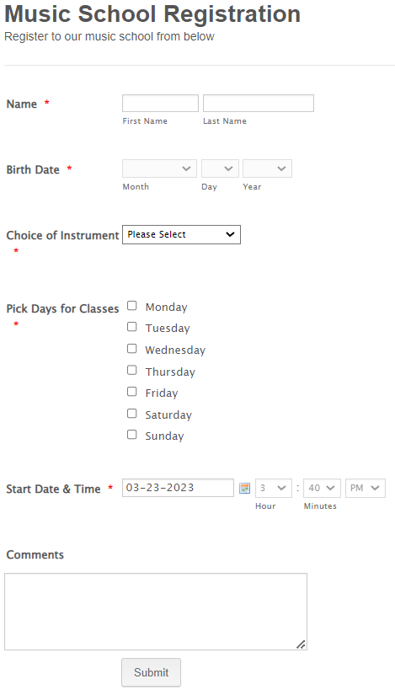

**Instructions**: Create database Music_School, and create table Music_Info. Insert data into database

**Charotar University of Science and Technology (CHARUSAT)**

**Faculty of: Computer Science and Applications**

**Name of the Institute: Smt. Chandaben Mohanbhai Patel Institute of Computer Applications**

**Academic Year:** 2022 - 23 **Semester:** VI  **Branch:** BSC(IT)

**Course code & Name:** CA610 Mobile Application Development  **Div:** II

**Examination: sessional Practical Examination Date:** 28 /03/2023

Q-1 Create an Application using Android [30]

**Set II**

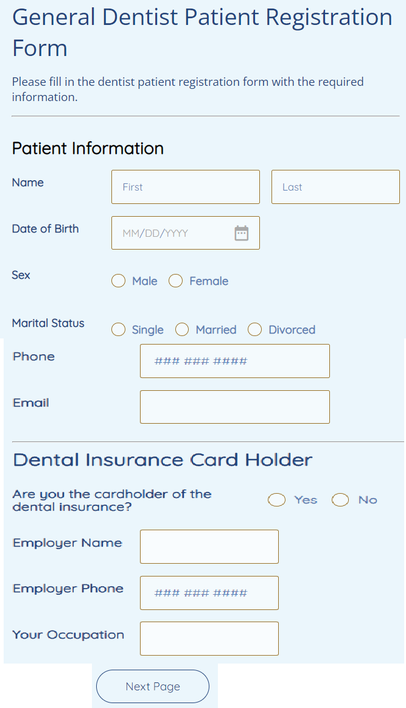

**Instructions**: Create database patient, and create table patient_Info. Insert data into database